Version Control

1. Need of version Control
2. What is version control
3. Types of version control

Git

Need of Version Control

Requirements from the client

1. We start developing the source code
2. We give demo to client
3. Again client give some changes to our requirement
4. We change the src code and gave 2nd demo
5. Again client give some changes to our requirement
6. We change the src code and gave 3nd demo
7. At finally the client 1st demo

Naming conversions in the version control

----------------------------------------------------------------------------

Version control: To avoid these limitations some people came up with the version control.

WorkSpace/ working directory: Where our source mainting in the our machince.

Repository: Maintaing source code in server is called Repository.

Commit: The process of moving source code from workspace to repository. This is commit

Checkout: The process of taking source code to local workspace is called checkout.

What is version control : Mainitaing our code in version format by using different version control tools

Ex: Git, SVN, Clearcase,Bitbucket…

Version control tool we can call as Source Code Management (SCM).

Types of Version Control

1. Centralized control system
2. Distrubuted control system/ decentralized control system.
3. Centralized control System:

Maintaining the single repository at single server. First we need to connect that server and need to do the changes.

It is easy to download and maintain.

Example: SVN, Clearcase…

Limitations of Centralized Control System:

1. Whenever all the developers connected at a time the server may goes down.
2. When on any server issue we cannot able to do changes in the repository.
3. We cannot able to do checkout or commit in the repository.
4. At the time demos, if the server is down , It leads to problematic.
5. Distributed Control System:

The process of maintaining the repositories in the multiple servers/ cloud basis is called distributes control System.

Example : Git

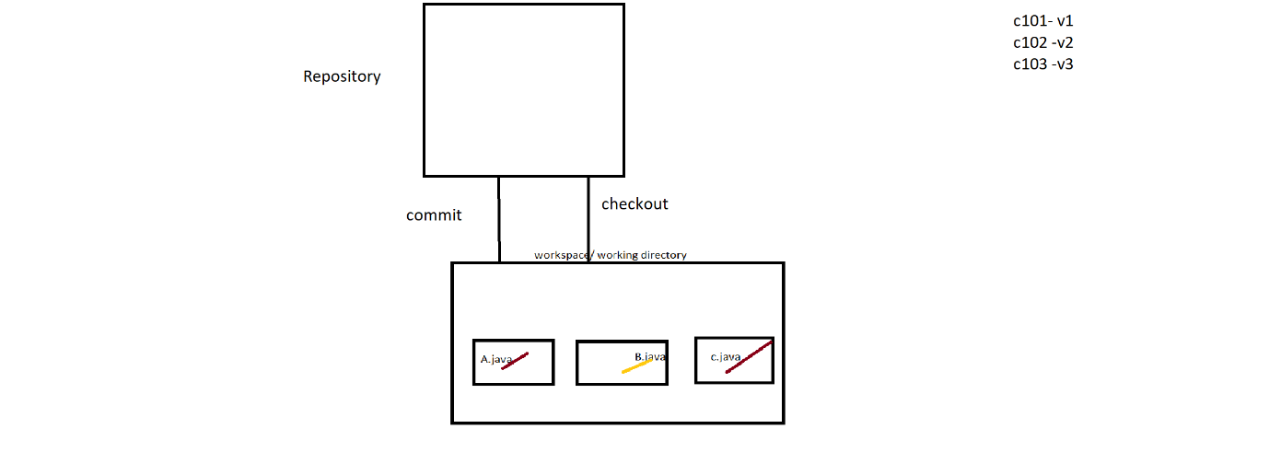

Git

Git is one of the distributed control system/ decentralized control system.

**How to create GitHub cloud**

1. Create an account in Github with mailId
2. Add a repository in the Github browser
3. Go to code in the Github browser as shown in below and copy the https link for cloning the code.

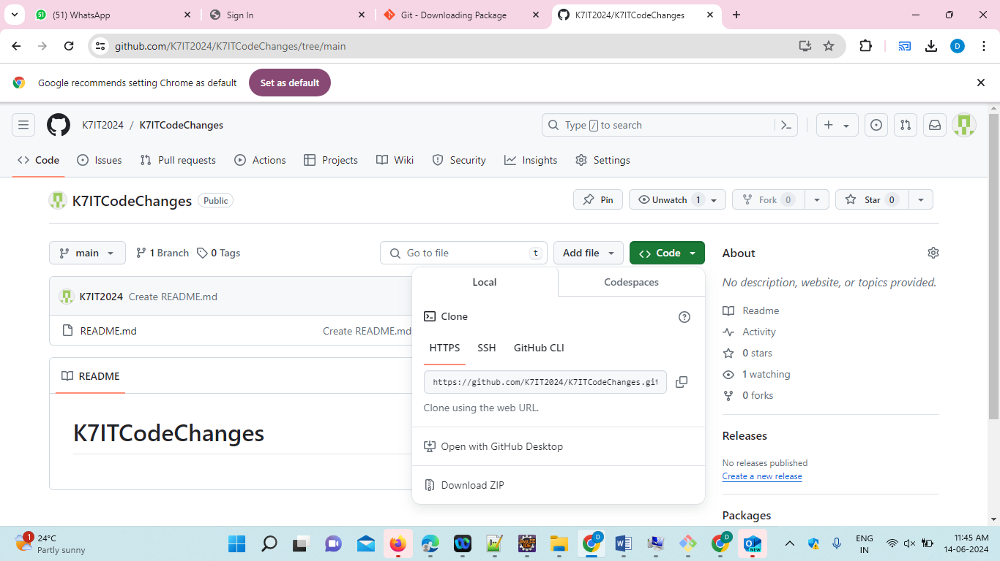

1. Download the Git.

<https://git-scm.com/downloads>

1. Install the git.exe file
2. Create the folder and right click and click on git bash.
3. Git clone **https://github.com/K7IT2024/K7ITCodeChanges.git**
4. Do the changes or add the practice files inside the folder.
5. Git init
6. Git add filename
7. Git status
8. Git branch <branch-name>
9. Git commit –m “message of the commit”
10. git remote add origin <https://github.com/K7ITech/K7IT4thBatch.git>
11. git push origin branch-name